# Chapter – 4 System Analysis and Planning

4.1 : UML(Unified Modeling Language)

4.1.1 : Use Case Diagram

4.1.2 : Activity Diagram

4.1.3 : Class Diagram

4.1.4 : Sequence Diagram

4.2 : System Flow Diagram

4.3 : Data Dictionary

4.4 : User Interface

4.5 : System Navigation

4.1 : UML(Unified Modeling Language)

4.1.1 : Use Case Diagram

* + Use case model for system consist of a set if use cases. Intuitively, use cases represent the different ways in which the users can use a system. Following is the use case representation of the advantages immigration system.
  + Use case diagram is a graphic depiction of the interactions among th elements of a system. A Use case is methodology used in system analysis to identify, clarity and organize system requirements.

|  |  |
| --- | --- |
|  | **Boundary of the System** |
|  | **Actor of the system** |
|  | **For Use case** |
|  | **Connector between the Actor and Use case.** |

1. Use-case of Neo bank System

2. Use-case of Admin

3. Use-case of Customer

4. Use-case of Investor

5. Use-case of Employee

1. Use-case of Neo bank System

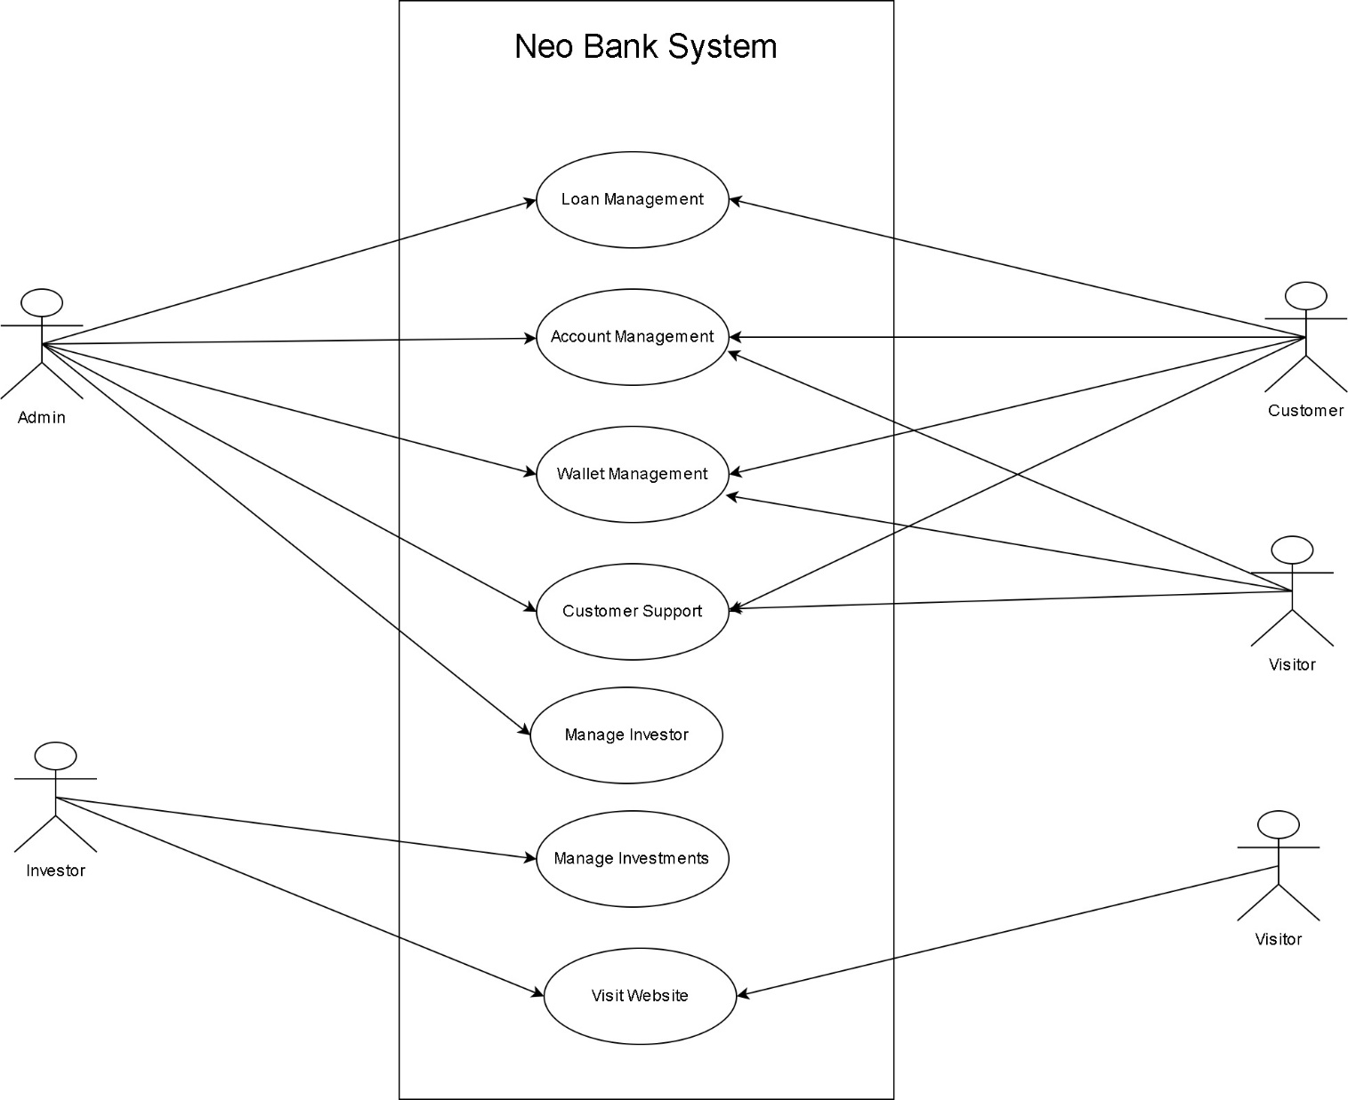

2. Use-case of Admin

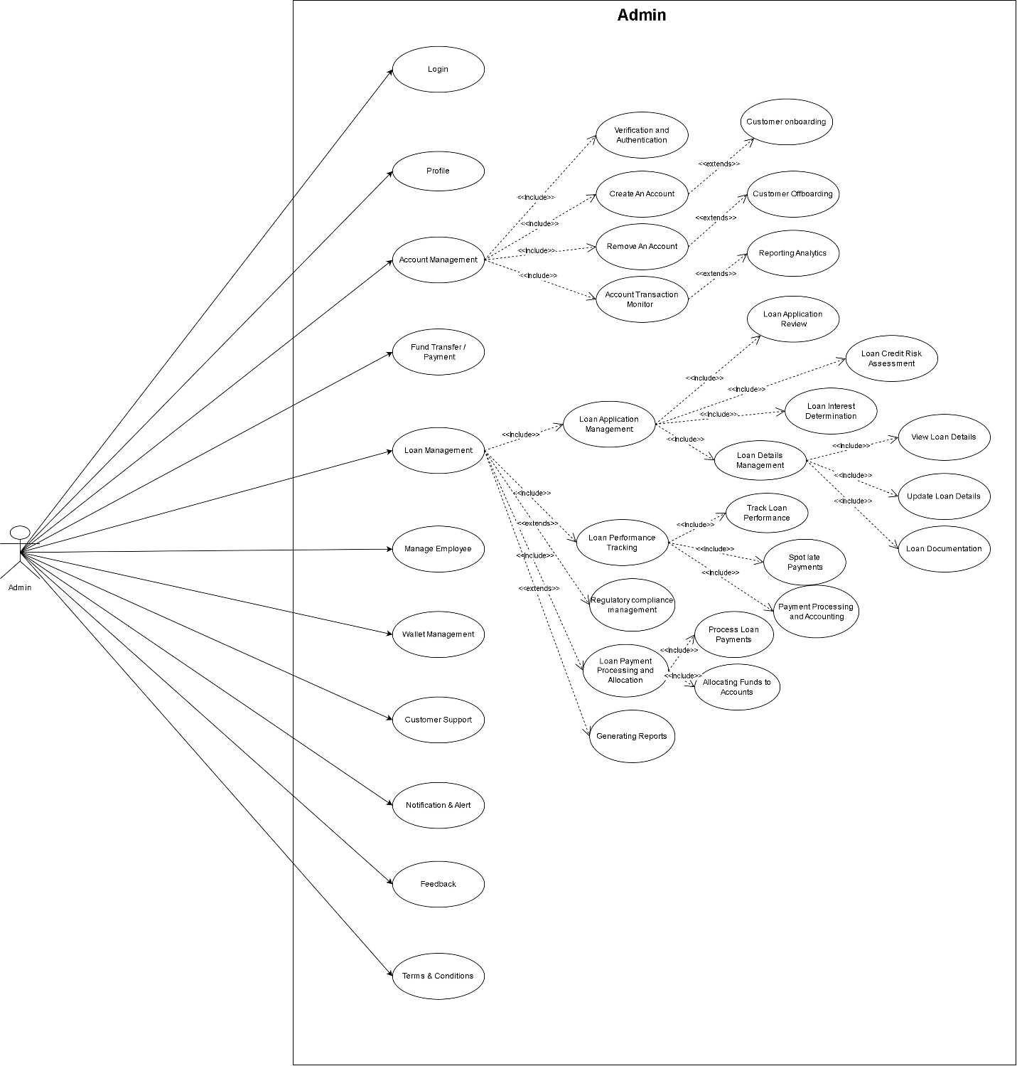

3. Use-case of Customer

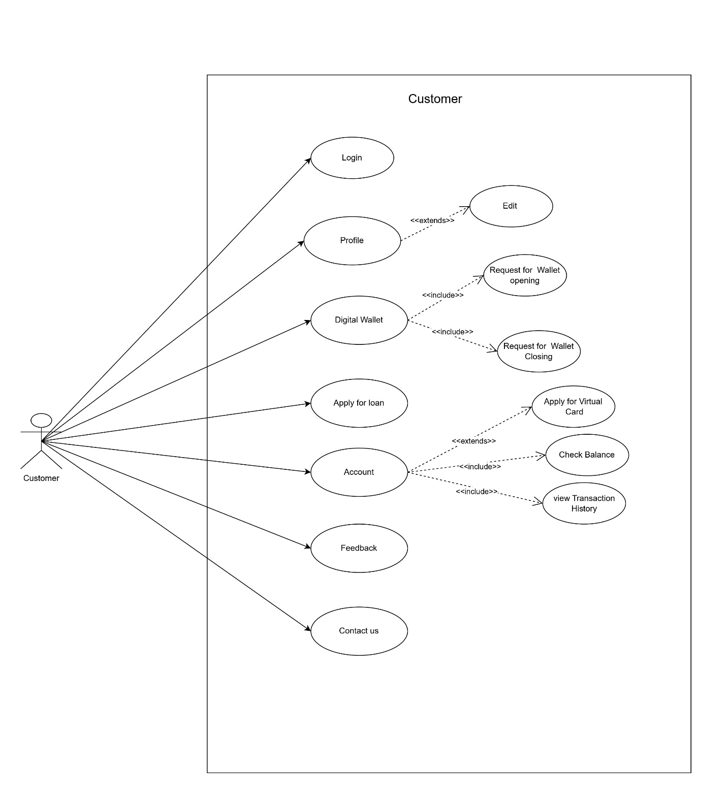

4. Use-case of Investor

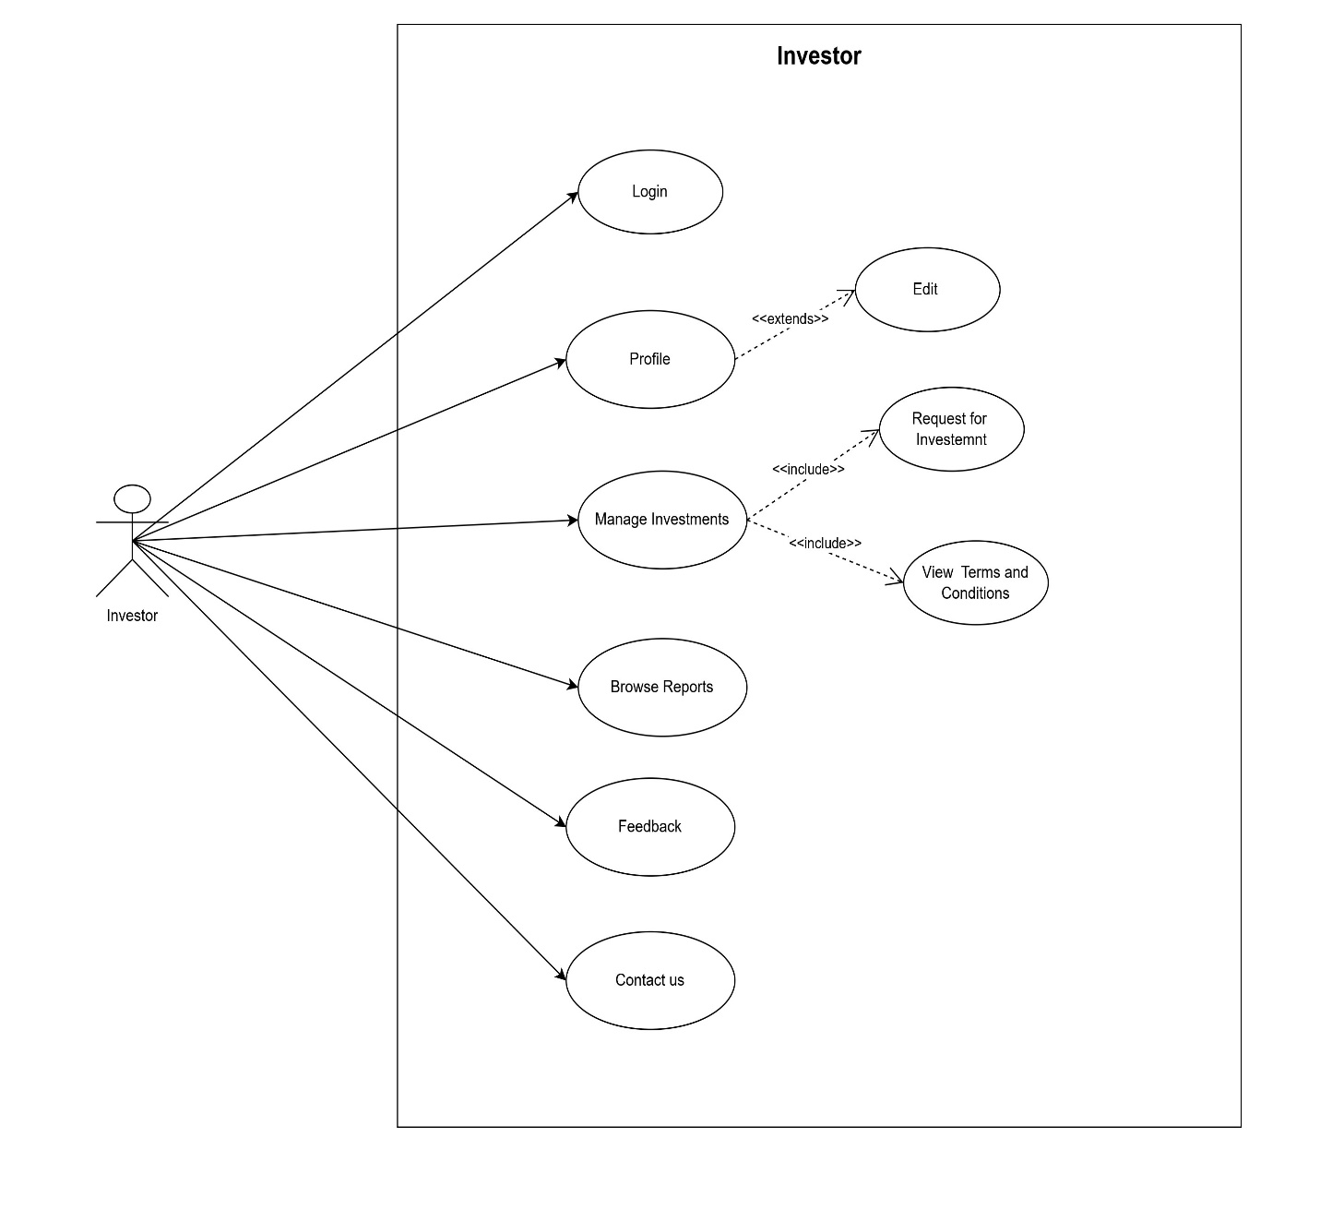

## 5. Use Case of Employee

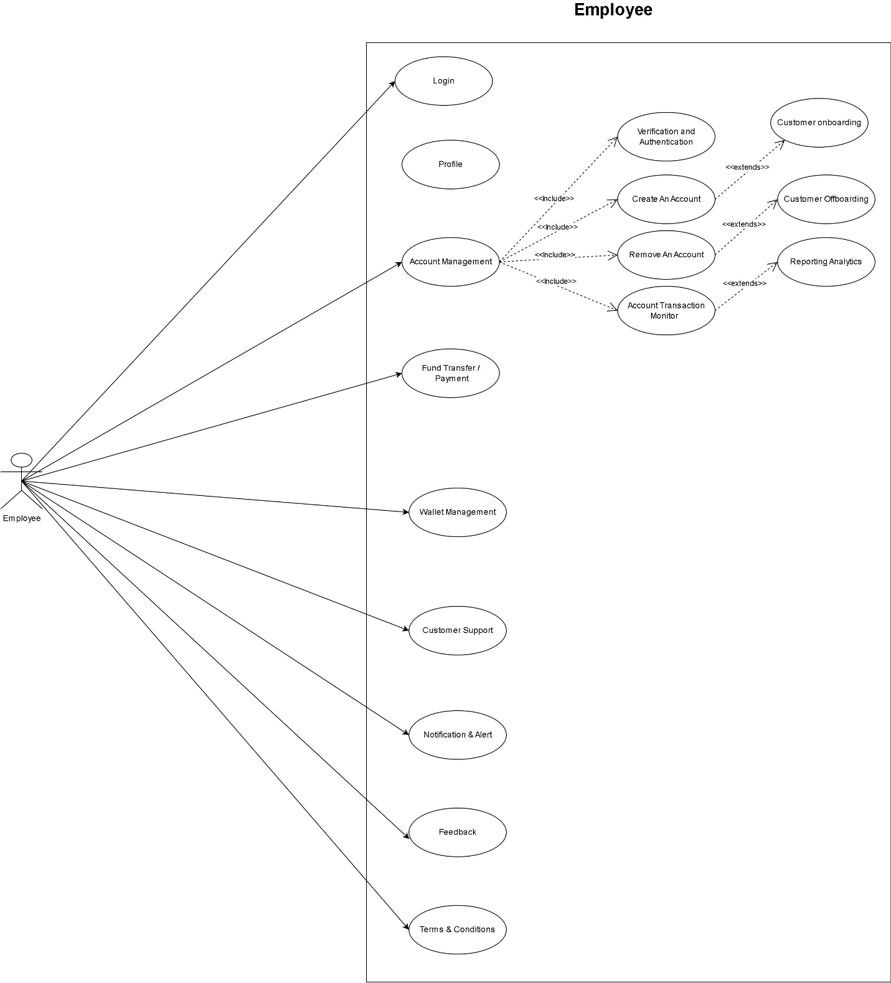

4.1.2 : Activity Diagram

Activity diagram is another important diagram in UML diagram describe dynamic aspects of the system. Activity diagram is basically a flow chart to represent the floe form one activity to another activity. The activity can be describe as an operation of the system.

|  |  |
| --- | --- |
|  | **Starting point of activity Diagram** |
|  | **Action Node** |
|  | **Join Action Node** |
|  | **Decision Node** |
|  | **Endpoint of Activity Diagram** |

1. Account Activity Diagram

2. Loan Activity Diagram

3. Card Activity Diagram

4. Payment Activity Diagram

1. Account Activity Diagram

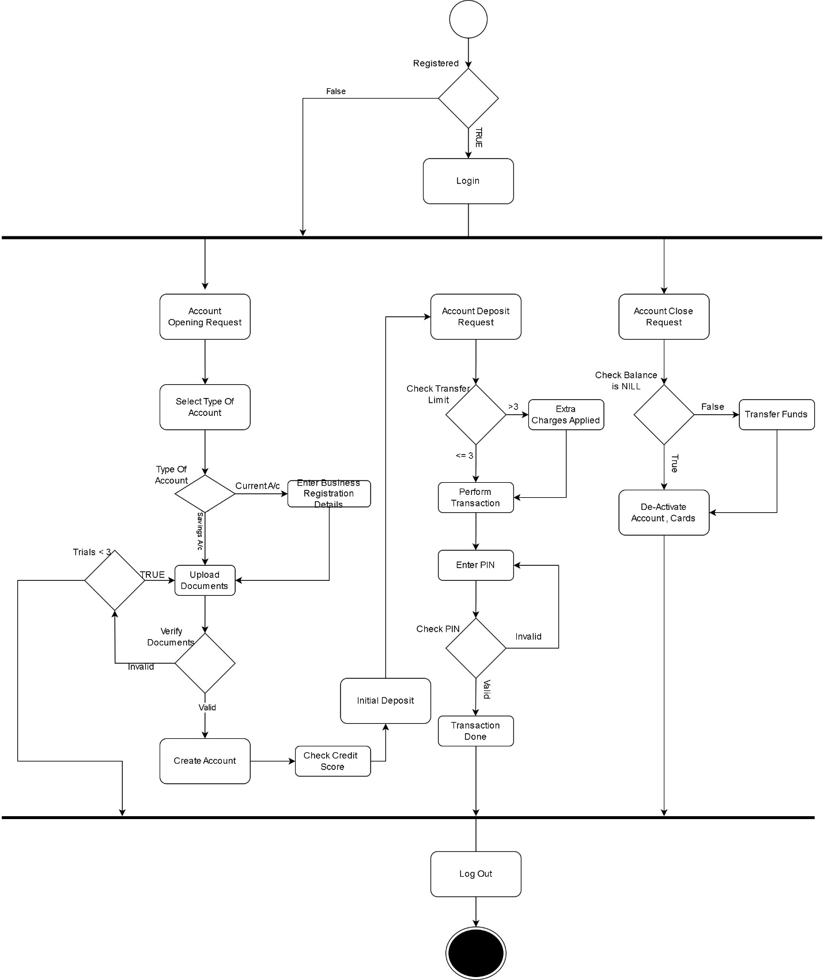

2. Loan Activity Diagram

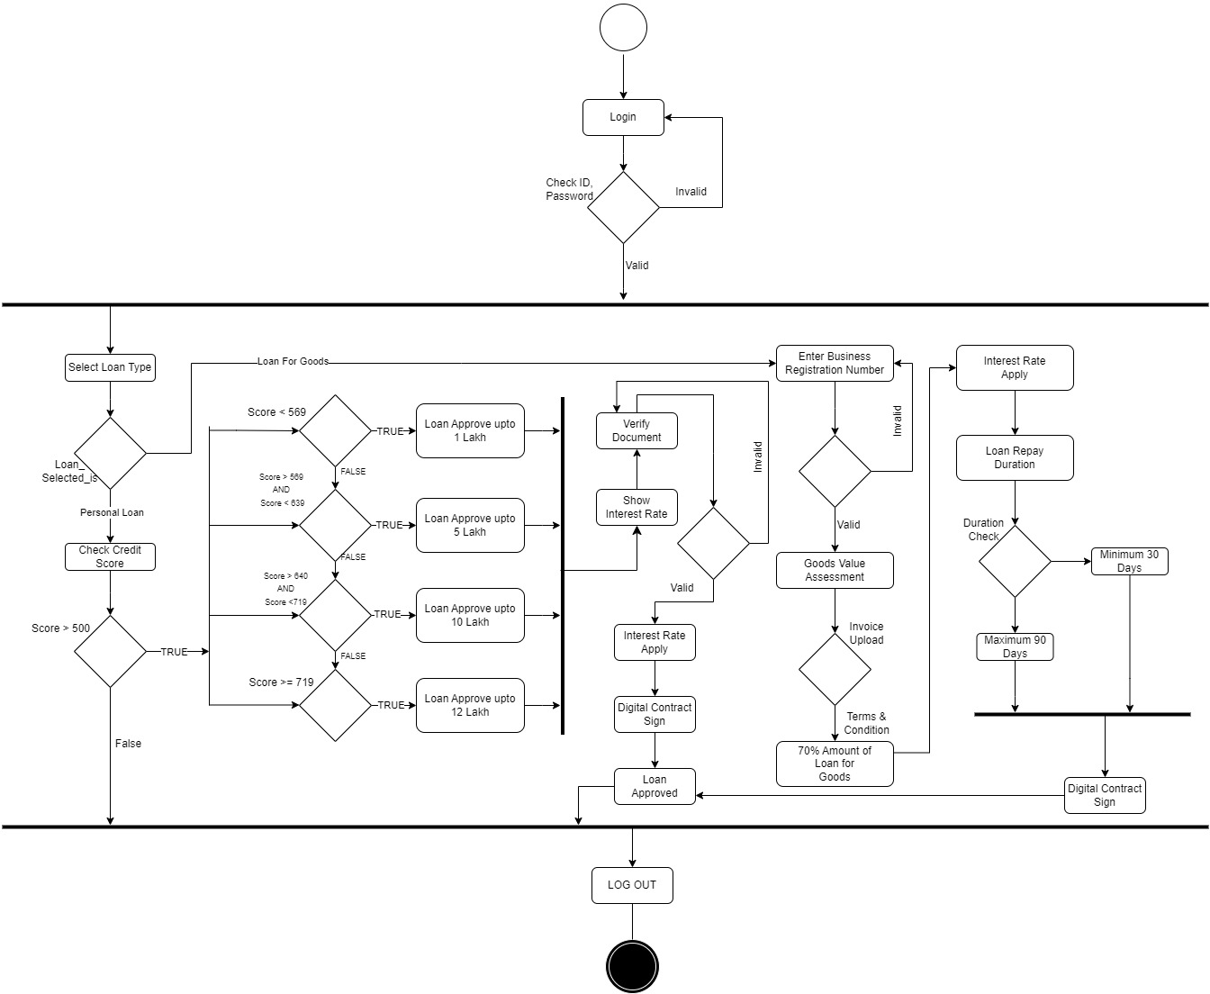

3. Card Activity Diagram

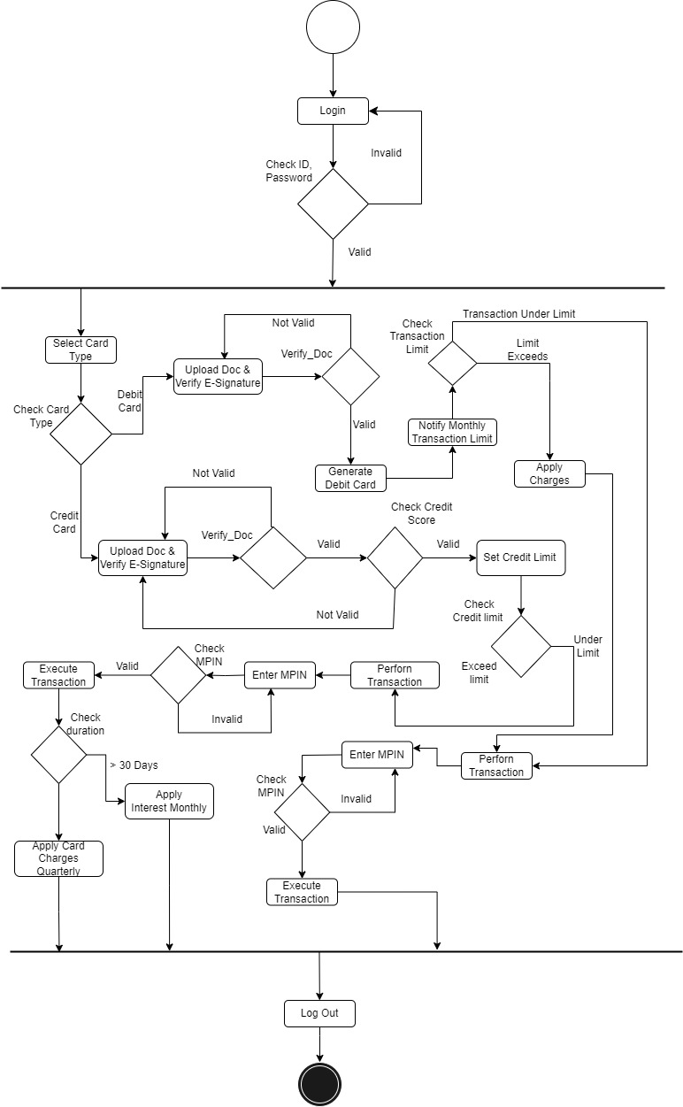

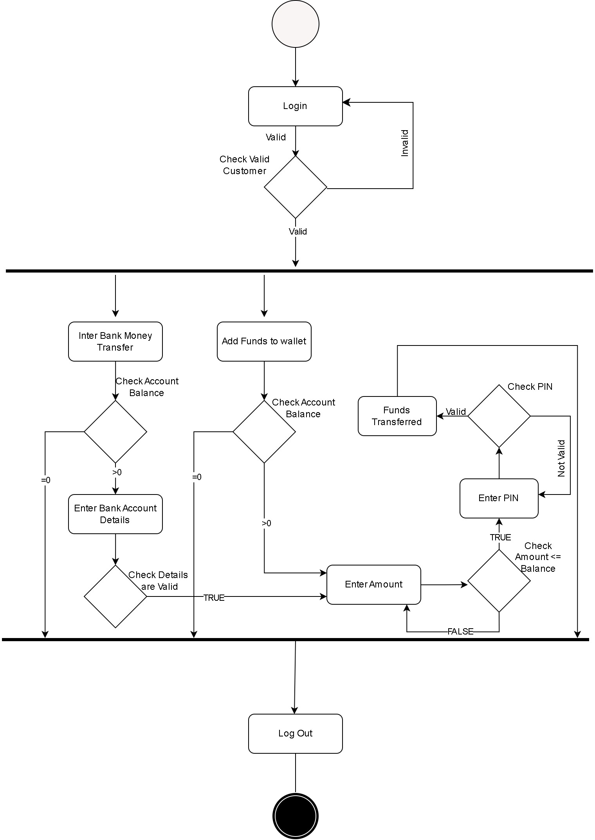4. Payment Activity Diagram

4.1.3 : Class Diagram

A class comprises of three sections:

* + - * + Class name
        + Structure(attributes)
        + Behavior(operations)

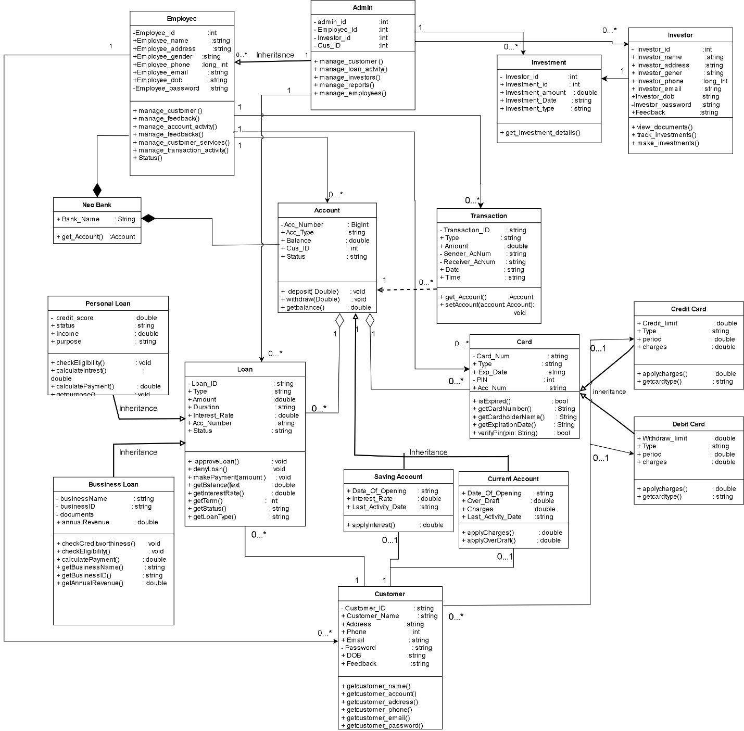

4.1.4 : Sequence Diagram

* + A sequence diagram simply depicts interaction between objects in a sequential order.
  + A sequence diagram is an interaction diagram that shows how objects operate with one another and in what order objects. In is a construct of a message sequence chart. A sequence diagram shows object interactions arranged in time sequence.

|  |  |
| --- | --- |
|  | Arrow represents and event occur between objects. |
|  | Rectangle represents Objects in Diagram. |
|  | Represents the Time occur between request and response of the object. |
|  | Back arrow represents response of the event to the objects. |

1. Admin Sequence Diagram

2. Customer Sequence Diagram

3. Investor Sequence Diagram

4. Employee Sequence Diagram

1. Admin Sequence Diagram

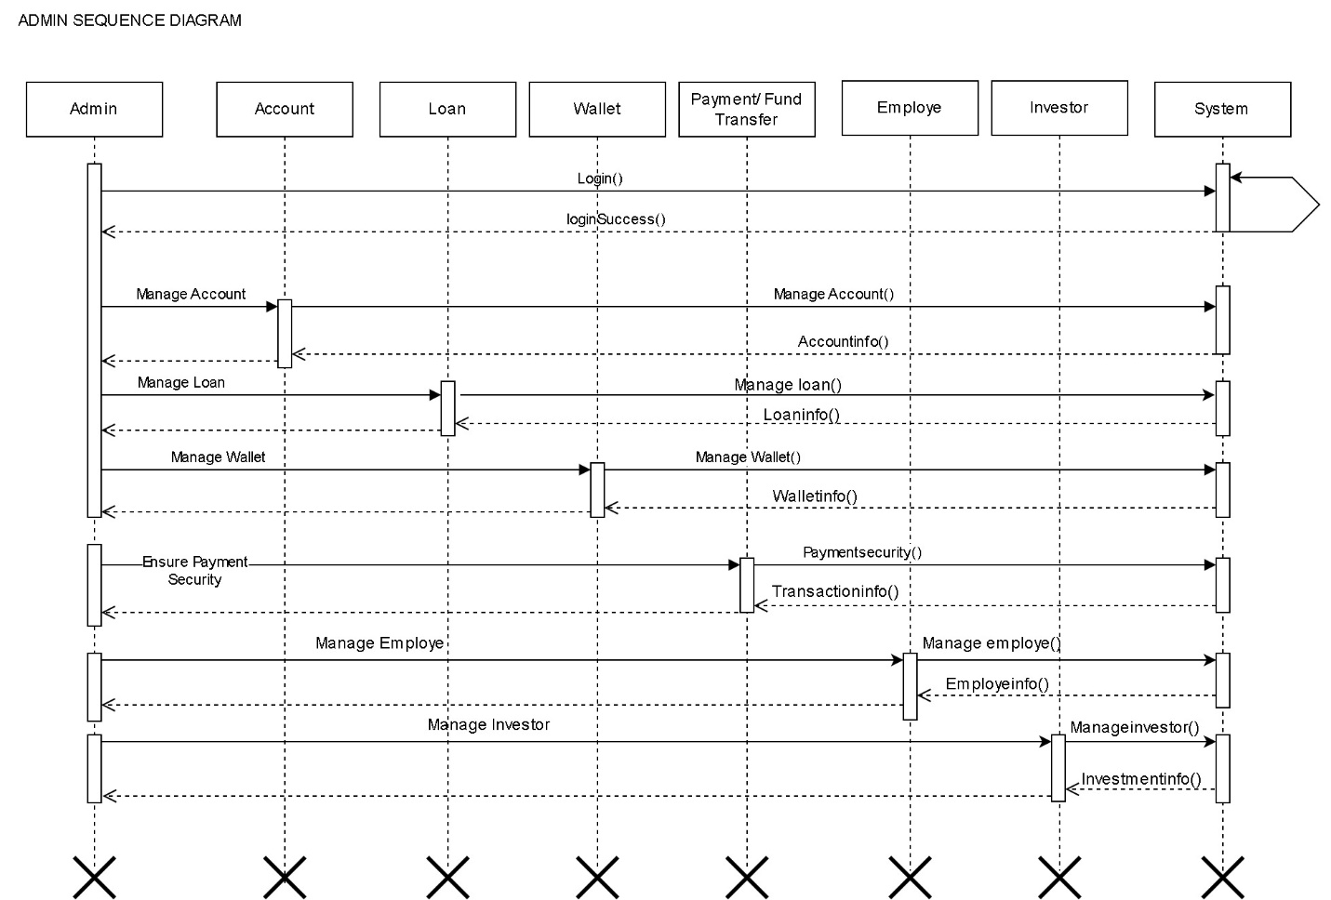

2. Customer Sequence Diagram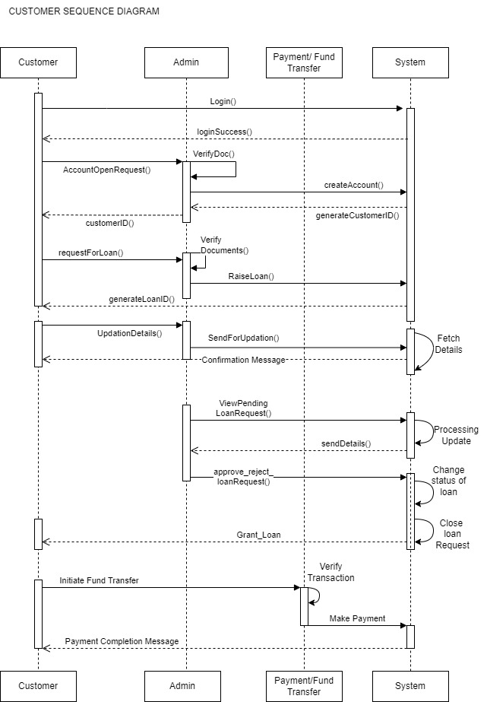

3. Investor Sequence Diagram

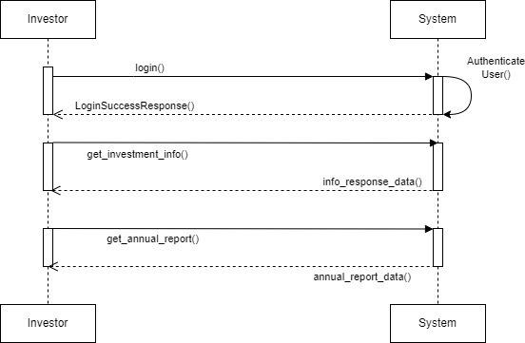

4. Employee Sequence Diagram

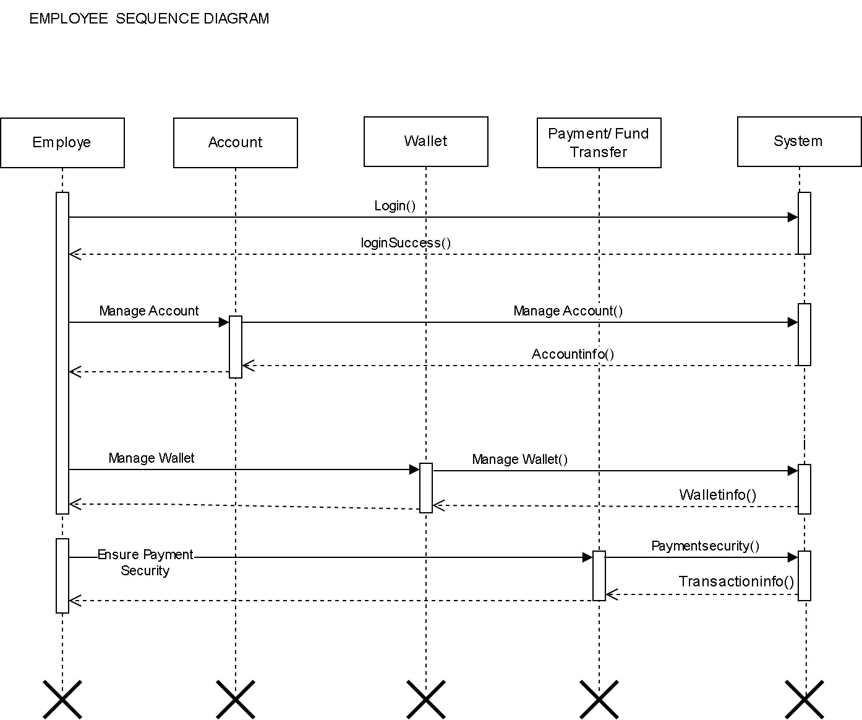

4.2 : System Flow Diagram

* This is diagram which helps to show the actual flow of the system that is how a system is going to work and what is it’s flow, from where it is starting and what are its functionalities and how we are going to exit out from our system.
* A SFD (System Flow Diagram) shows what kind of information will be input to and output from the system where the data will come from and go to, and where the data will be stored. It gives the clear idea about the whole process, say it an application or a normal data flow.

|  |  |
| --- | --- |
|  | **Start/End** |
|  | **Arrows** |
|  | **Data** |
|  | **Process** |
|  | **Decision** |

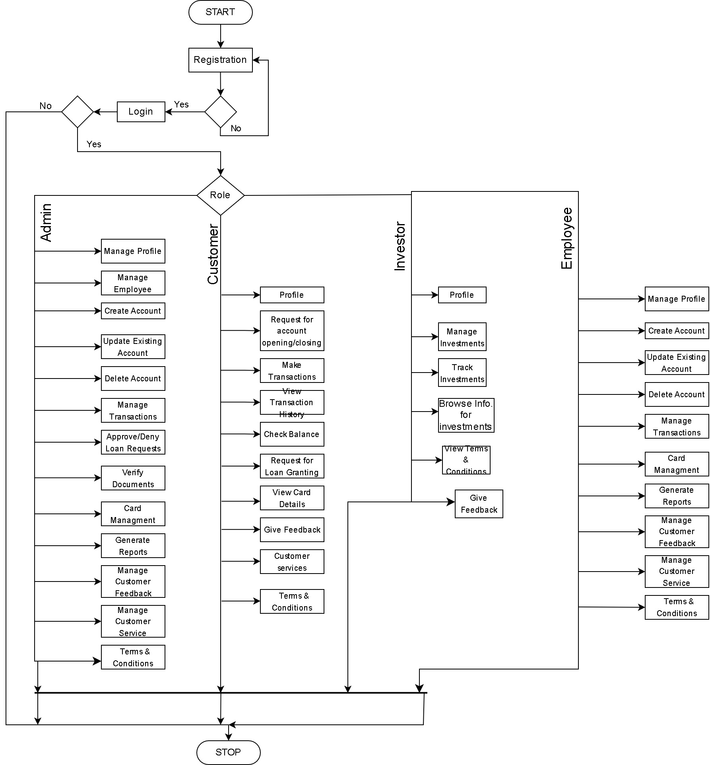

4.3 : Data Dictionary

1. Account Table :-

Primary Key = Account_number

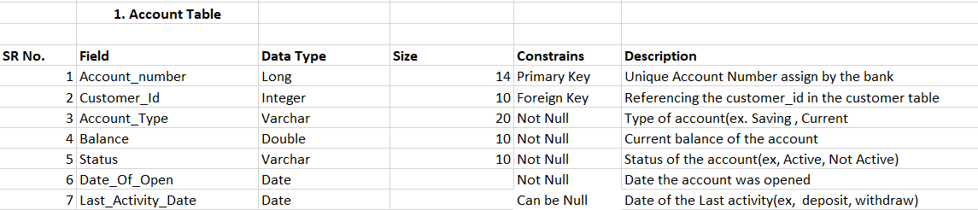

2. Current Account Table :-

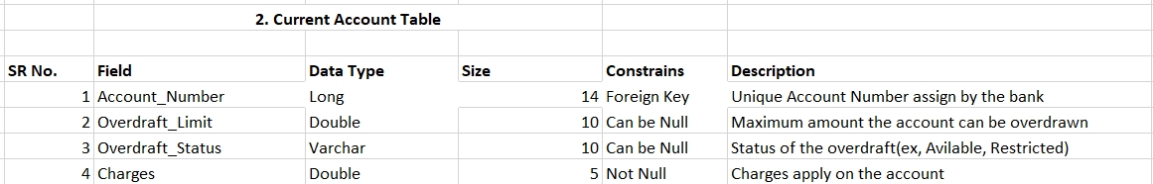

1. Saving Account Table :-

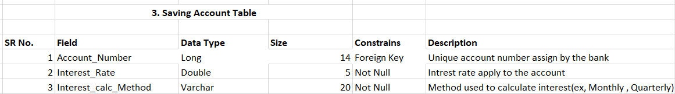

1. Card Table :-

Primary Key = Card_Number

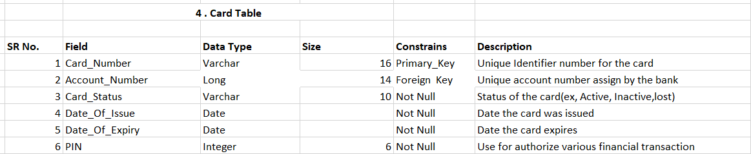

1. Credit Card Table :-

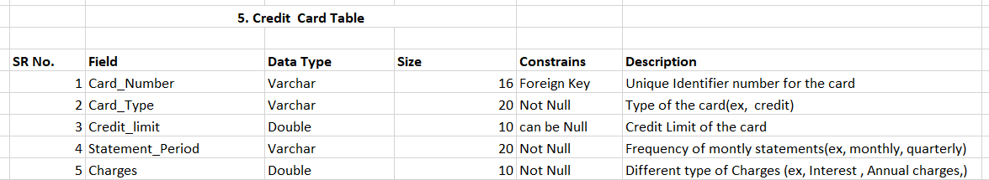

1. Debit Card Table :-

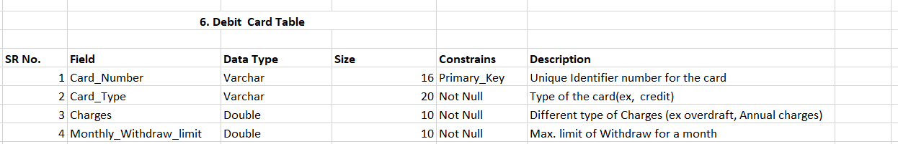

1. Transaction Table :-

Primary Key = Transaction_id

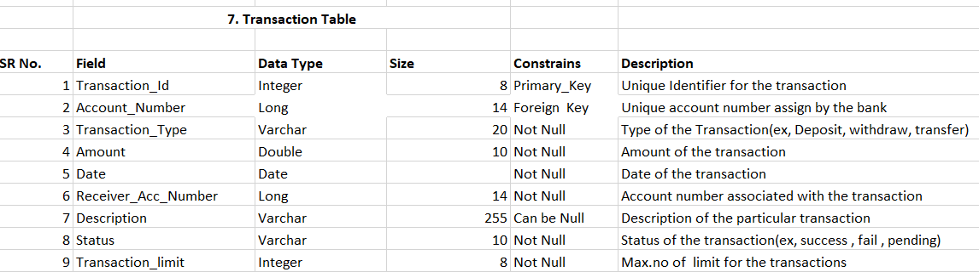

1. Customer Table :-

Primary Key = Customer_id

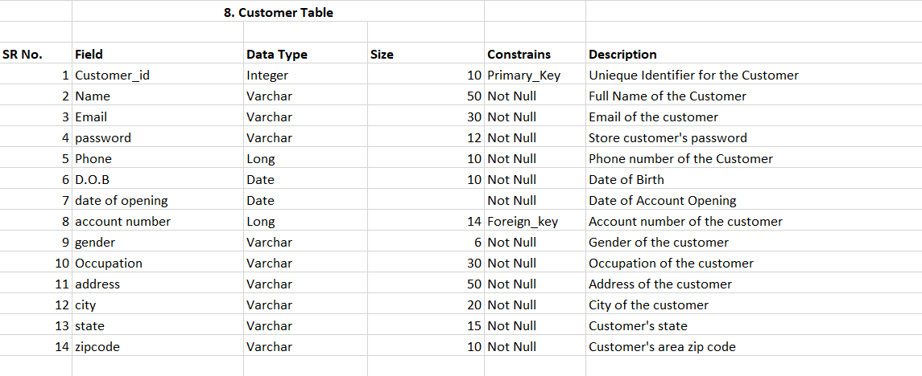

1. Loan Table :-

Primary Key :- Loan_id

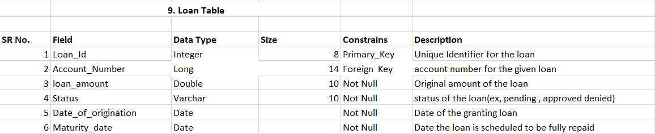

1. Personal Loan Table :-

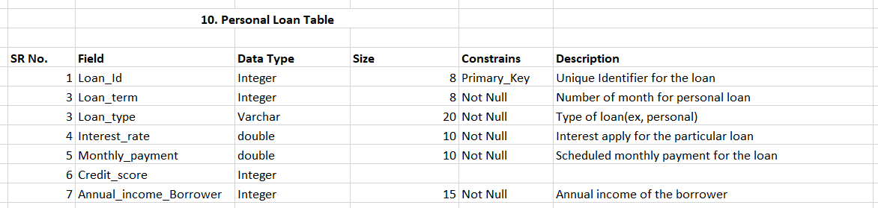

1. Business Loan Table :-

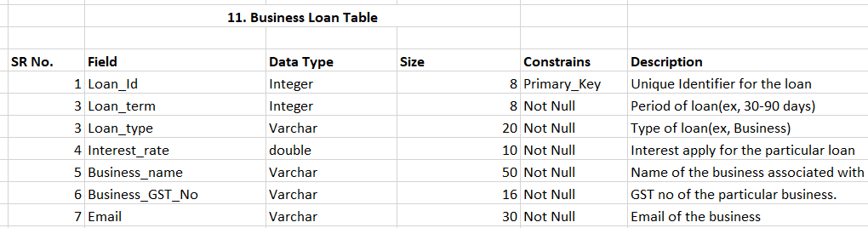

1. Employee Table :-

Primary Key :- Employee ID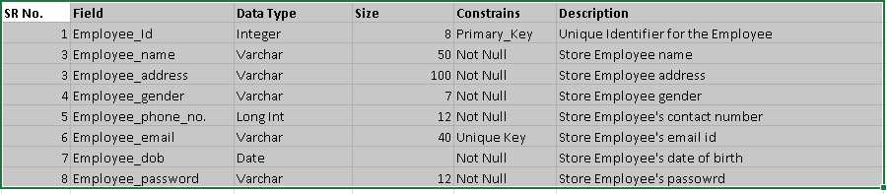

1. Feedback Table :-

Primary Key :- Feedback ID

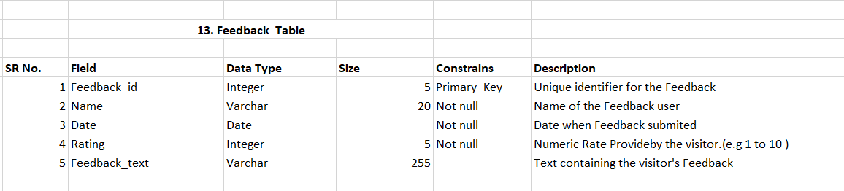

14.Investor Table :-

Primary Key :- Investor ID

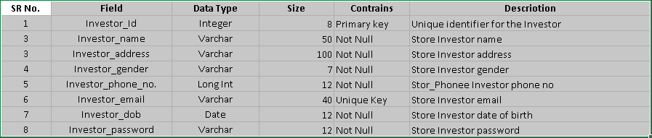

15.Investment Table :-

Primary Key :- Investment ID

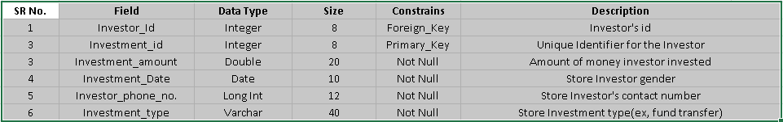

16.Admin Table :-

Primary Key :- Admin ID

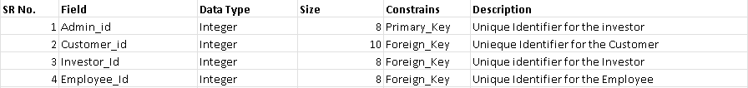

4.4 : User Interface :-

Home Page

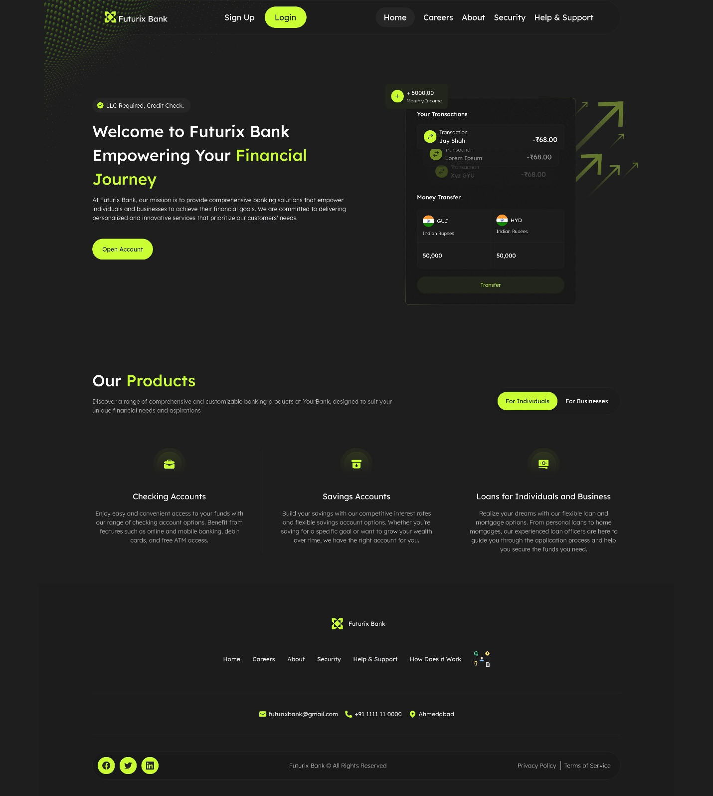

Sign Up Page

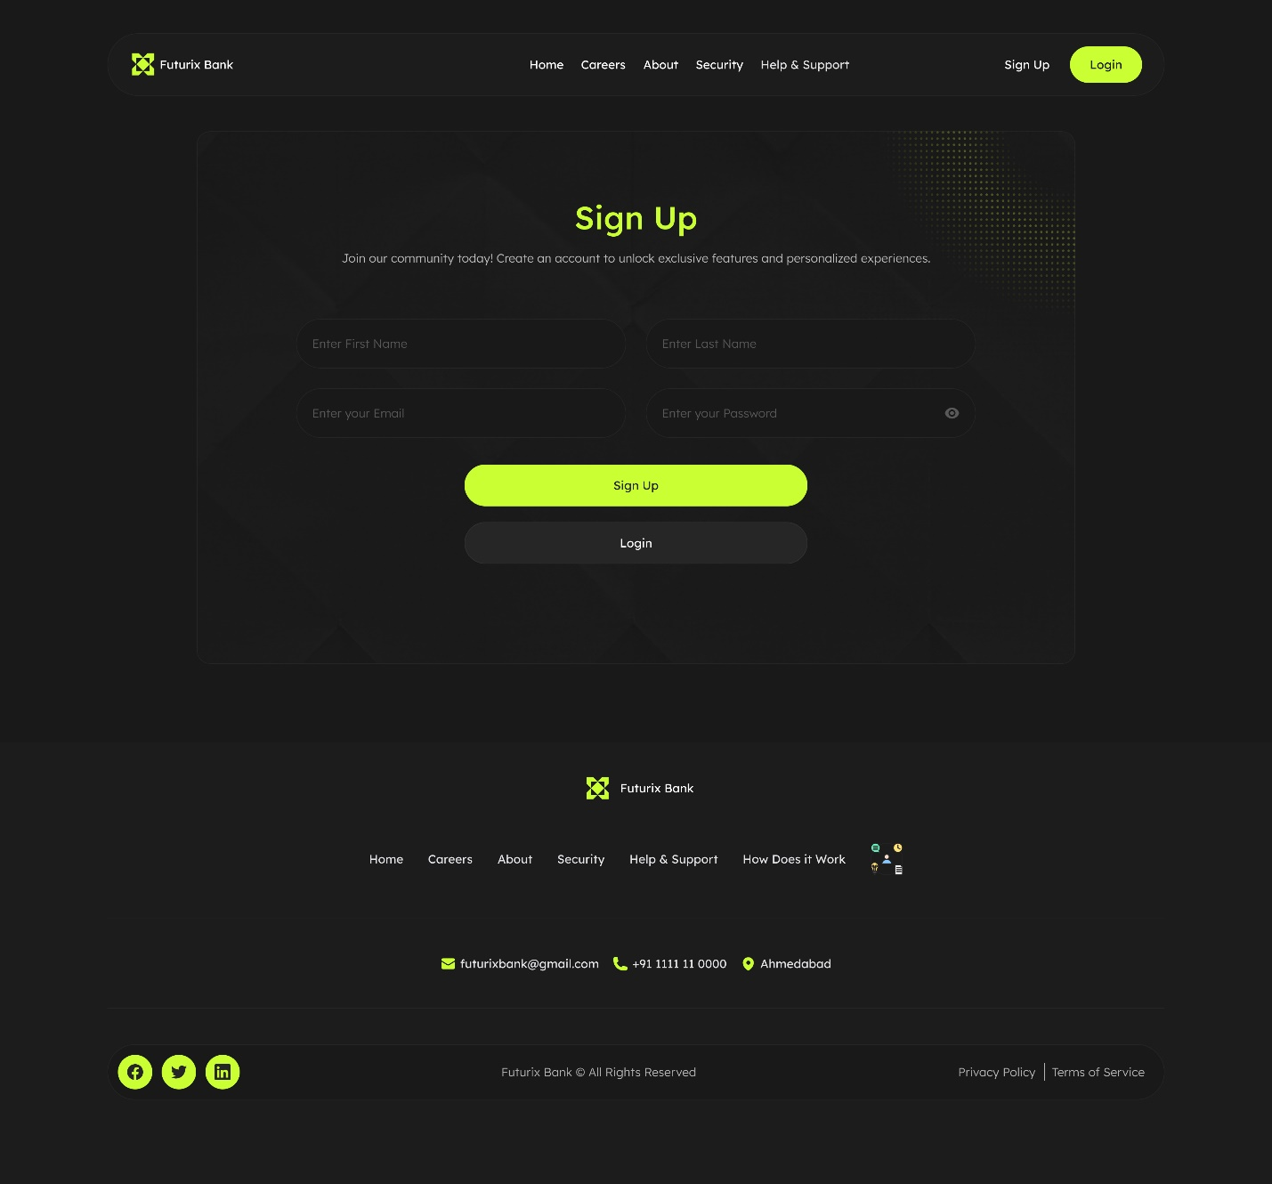

Login Page

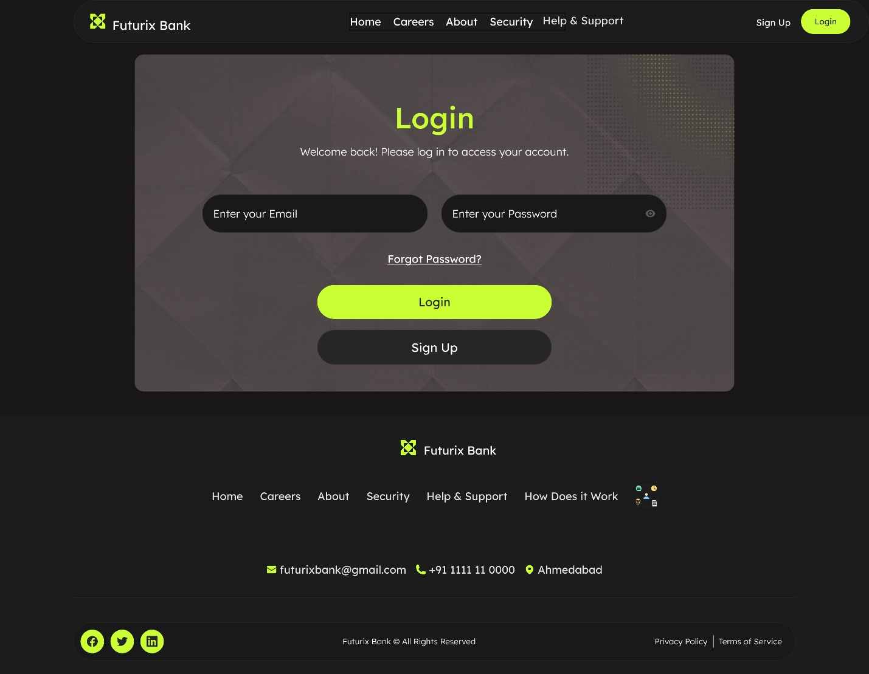

Digital Credit Card

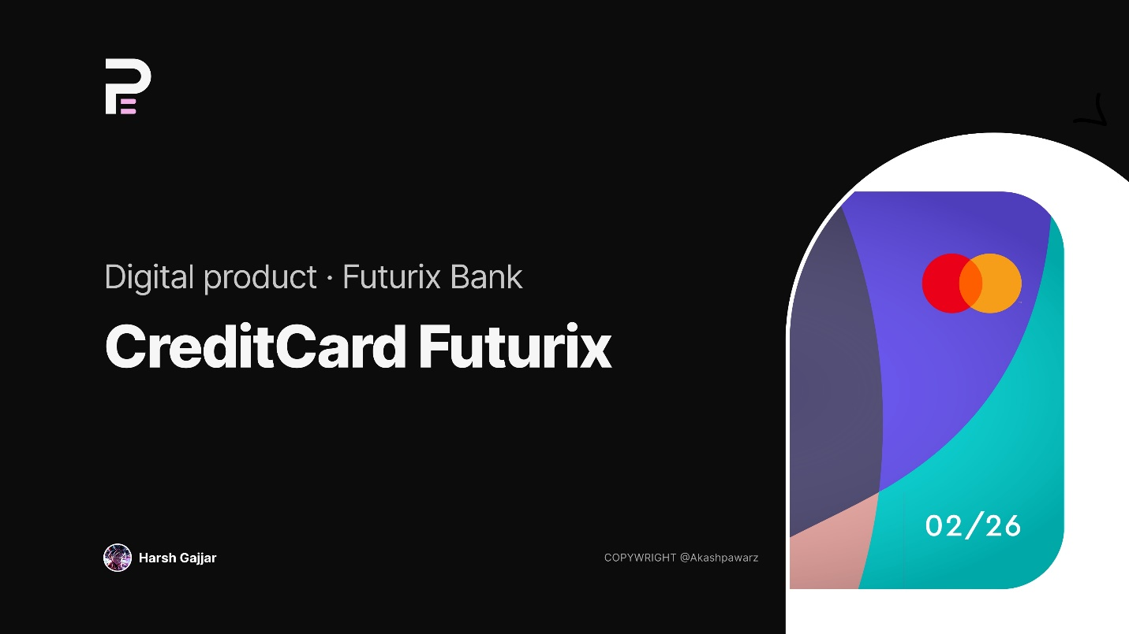

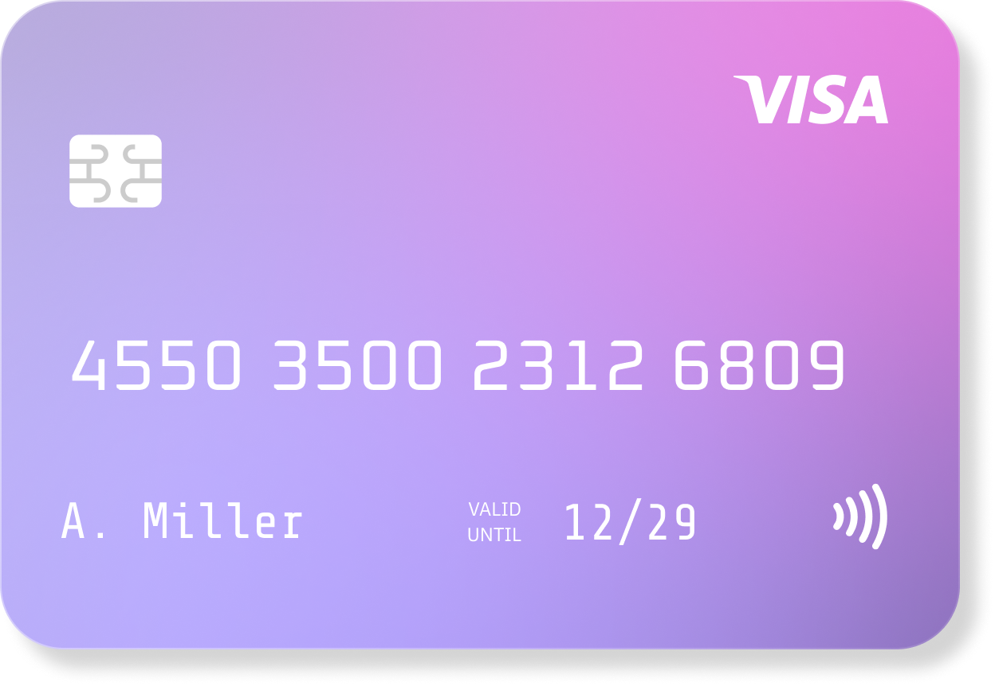

Digital Debit Card

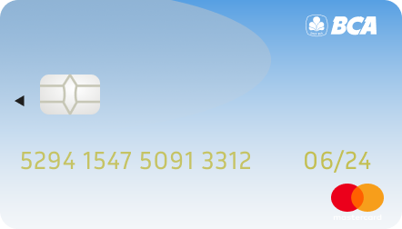

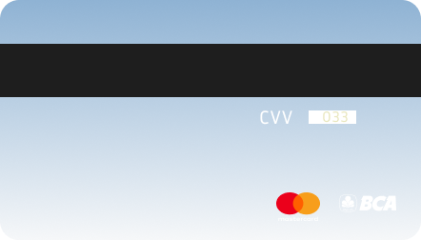

4.5 : System Navigation :-

